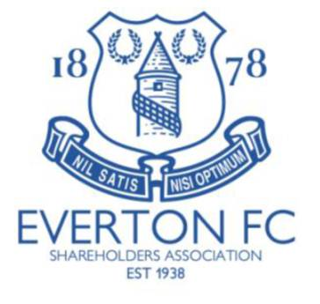

PRESS RELEASE: MARCH 2023

The Everton Shareholders’ Association is disappointed and concerned that despite the Chair of Everton Football Club Bill Kenwright, and the majority shareholder Farhad Moshiri saying in the Zoom Meeting of July 2022 that they had no objection to having Annual General Meetings, no meeting has taken place for more than two years.

The Club via its Chief Executive has indicated that it has no intention at this time of reinstating General Meetings. The Shareholders’ Association, shareholders in general and indeed the wider fan-base are disappointed by the board’s decision.

We respectfully request the Chair, and the Majority Shareholder exercise their authority, remembering that General Meetings are a decision for shareholders and not employees of Everton Football Club, to commit to a General Meeting before the end of the current Financial Year.

